<https://docdro.id/fIYPp6K>

About Interrupts, Exceptions, Traps and Signals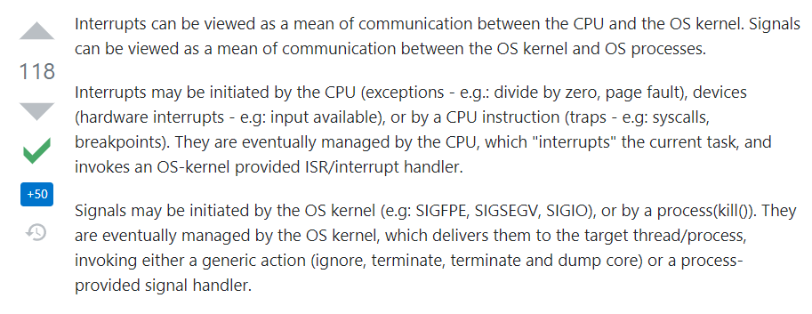:-

[Synchronous and Asynchronous I/O - Win32 apps | Microsoft Docs](https://docs.microsoft.com/en-us/windows/win32/fileio/synchronous-and-asynchronous-i-o?redirectedfrom=MSDN) (IMP)

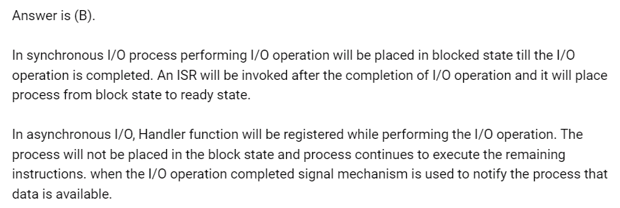

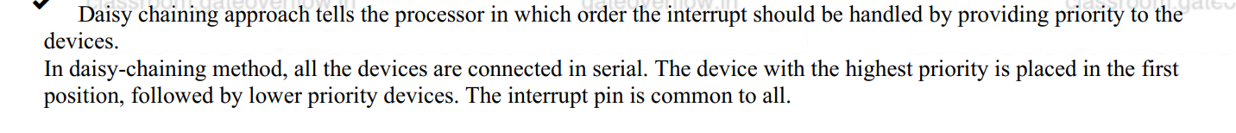



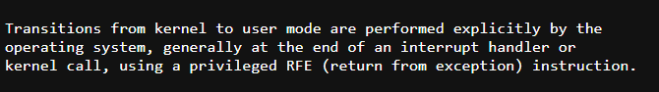

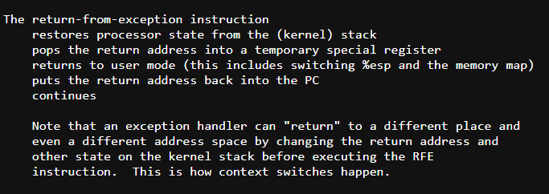

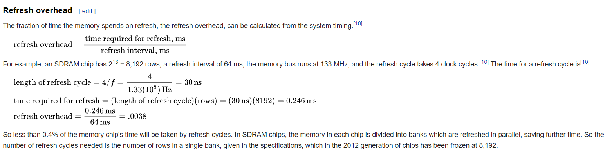

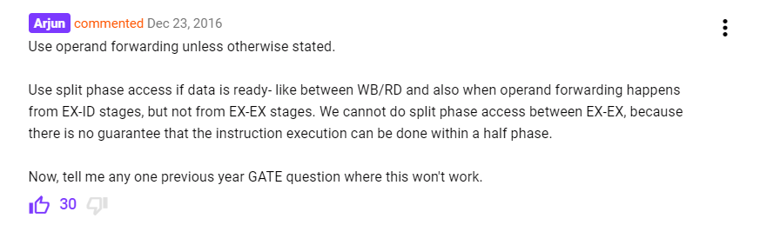

All time best q : [CO and Architecture: GATE CSE 2005 | Question: 68 (gateoverflow.in)](https://gateoverflow.in/1391/gate-cse-2005-question-68)

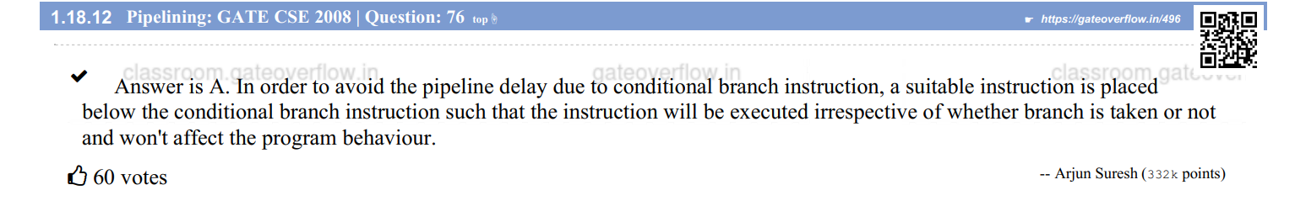

V.IMP: Non linear pipeline minimum avg latency (MAL) = [Lecture 41 : PIPELINE SCHEDULING - YouTube](https://www.youtube.com/watch?v=Z9gvdQU6IAE)

Q: 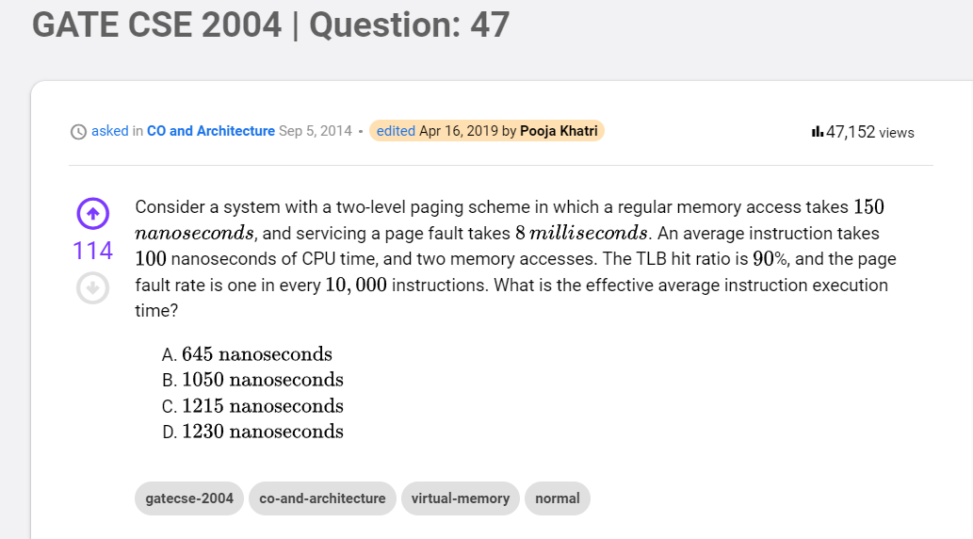

Ans:

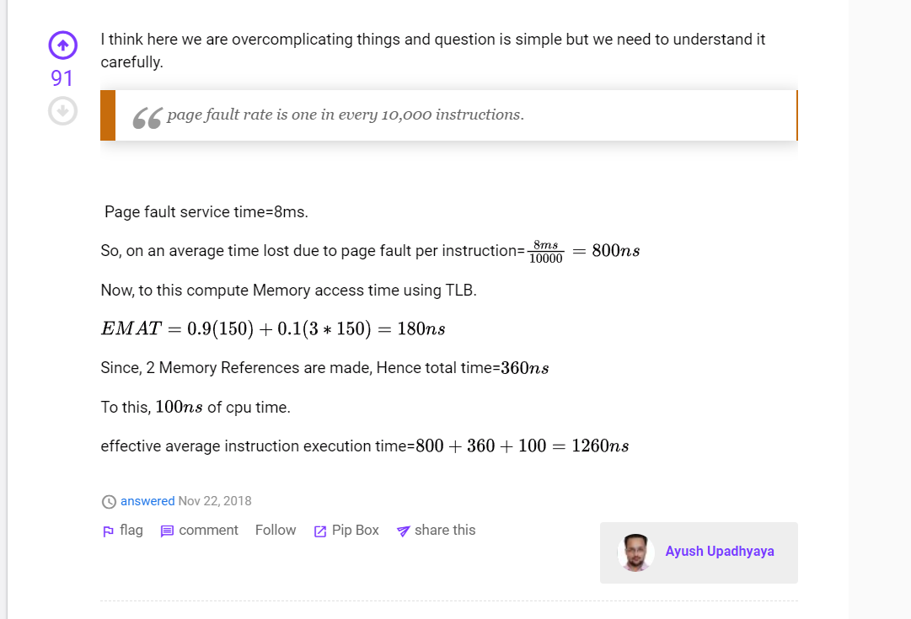

Q: 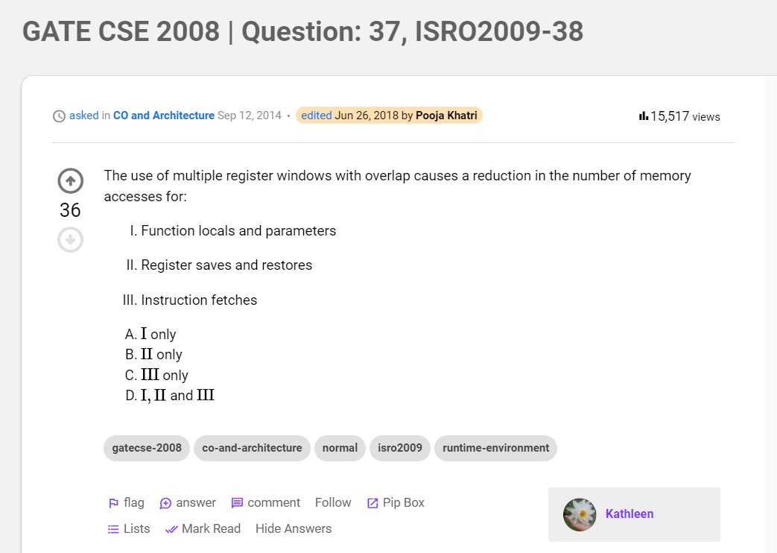

Ans:

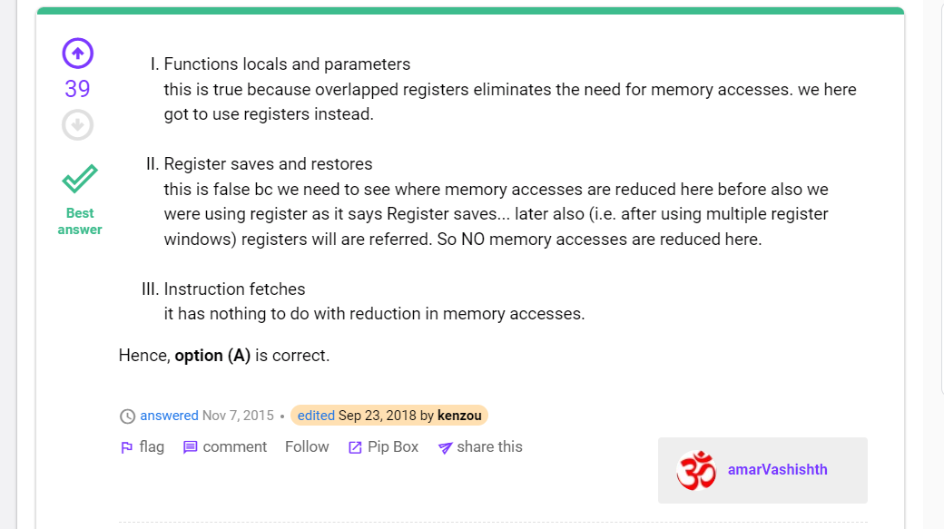

The Best answer on Operand Forwarding : [CO and Architecture: GATE CSE 2005 | Question: 68 (gateoverflow.in)](https://gateoverflow.in/1391/gate-cse-2005-question-68) MUST MUST READ

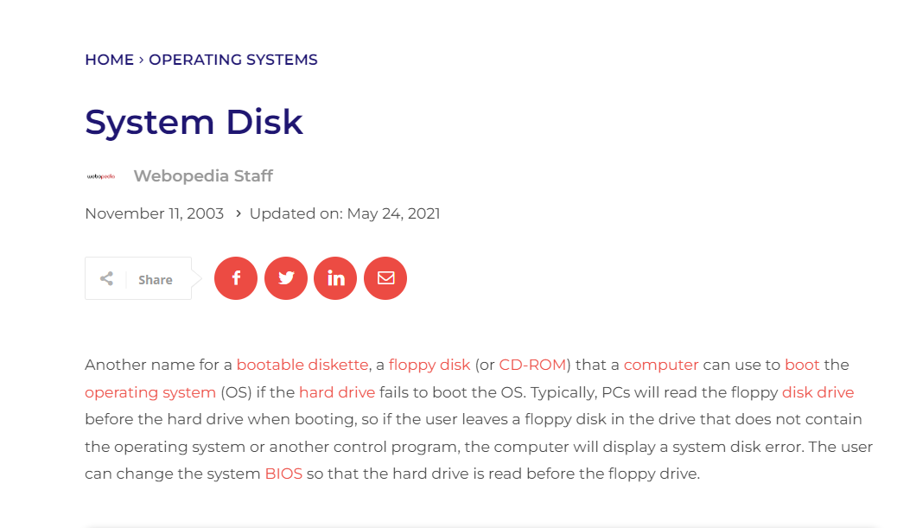

<https://gateoverflow.in/388687/go-classes-test-series-2023-mock-gate-test-2-question-37?show=395437#c395437>

[CO and Architecture: MadeEasy Test Series: CO & Architecture - Cache Memory (gateoverflow.in)](https://gateoverflow.in/91103/madeeasy-test-series-co-%26-architecture-cache-memory)

[CO and Architecture: GO Classes Test Series 2023 | CO and Architecture | Test 3 | Question: 12 (gateoverflow.in)](https://gateoverflow.in/381906/go-classes-test-series-2023-and-architecture-test-question)

[CO and Architecture: GO Classes Test Series 2023 | CO and Architecture | Test 3 | Question: 10 (gateoverflow.in)](https://gateoverflow.in/381910/go-classes-test-series-2023-and-architecture-test-question)

[CO and Architecture: GO Classes Test Series 2023 | CO and Architecture | Test 3 | Question: 8 (gateoverflow.in)](https://gateoverflow.in/381914/go-classes-test-series-2023-and-architecture-test-question)

[CO and Architecture: GO Classes Test Series 2023 | CO and Architecture | Test 3 | Question: 4 (gateoverflow.in)](https://gateoverflow.in/381922/go-classes-test-series-2023-and-architecture-test-question)

[CO and Architecture: GO Classes Test Series 2023 | CO and Architecture | Test 3 | Question: 2 (gateoverflow.in)](https://gateoverflow.in/381926/go-classes-test-series-2023-and-architecture-test-question)

[CO and Architecture: GO Classes Test Series 2023 | CO and Architecture | Test 3 | Question: 15 (gateoverflow.in)](https://gateoverflow.in/381900/go-classes-test-series-2023-and-architecture-test-question)